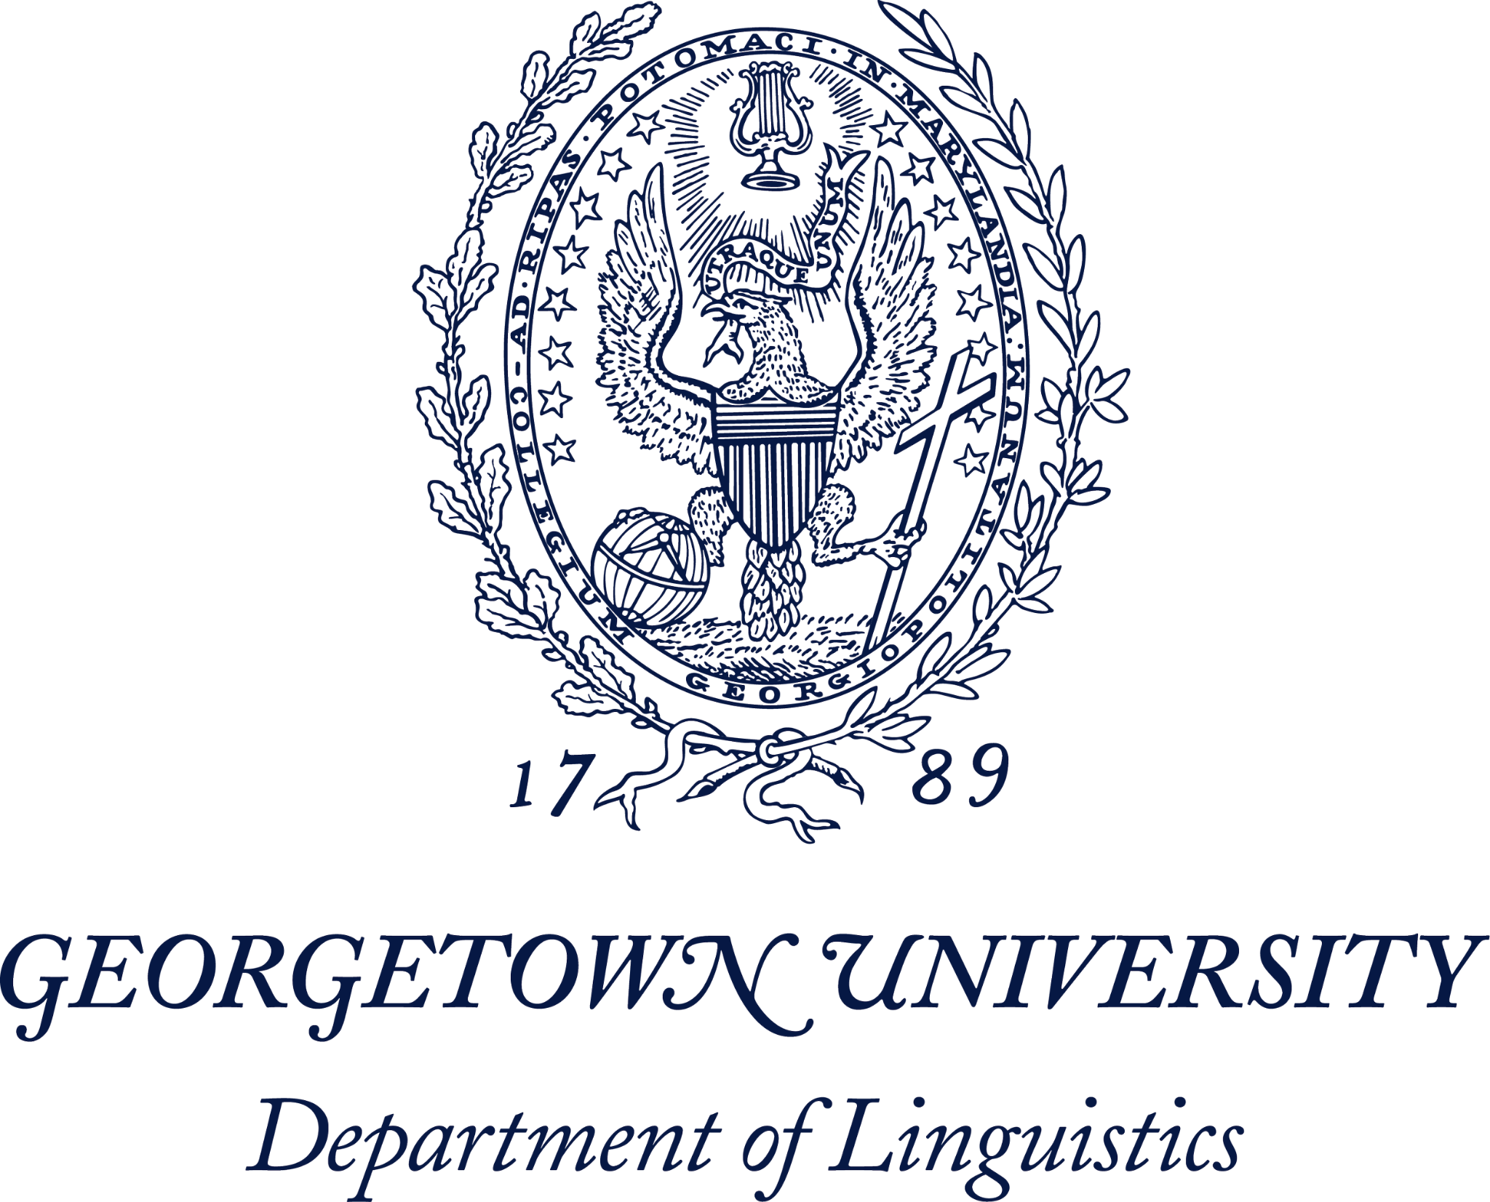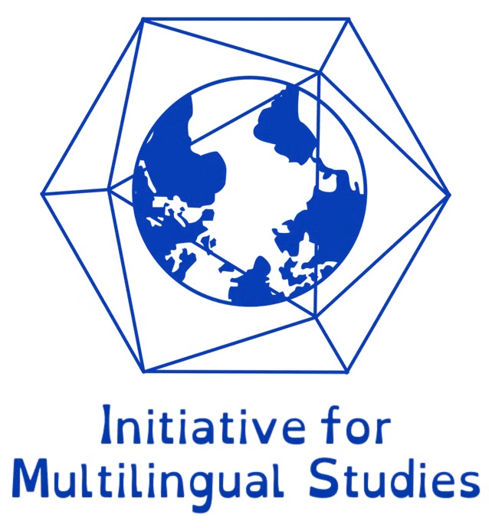

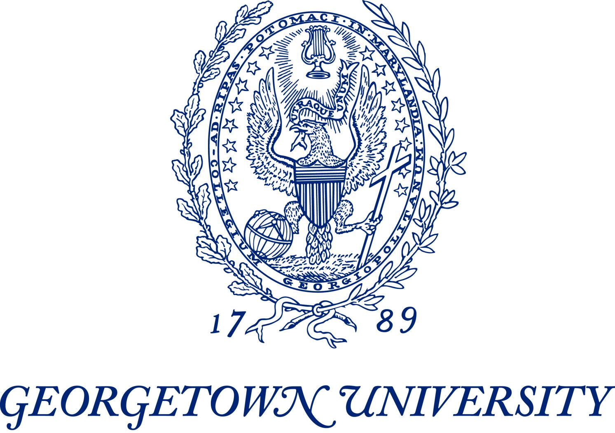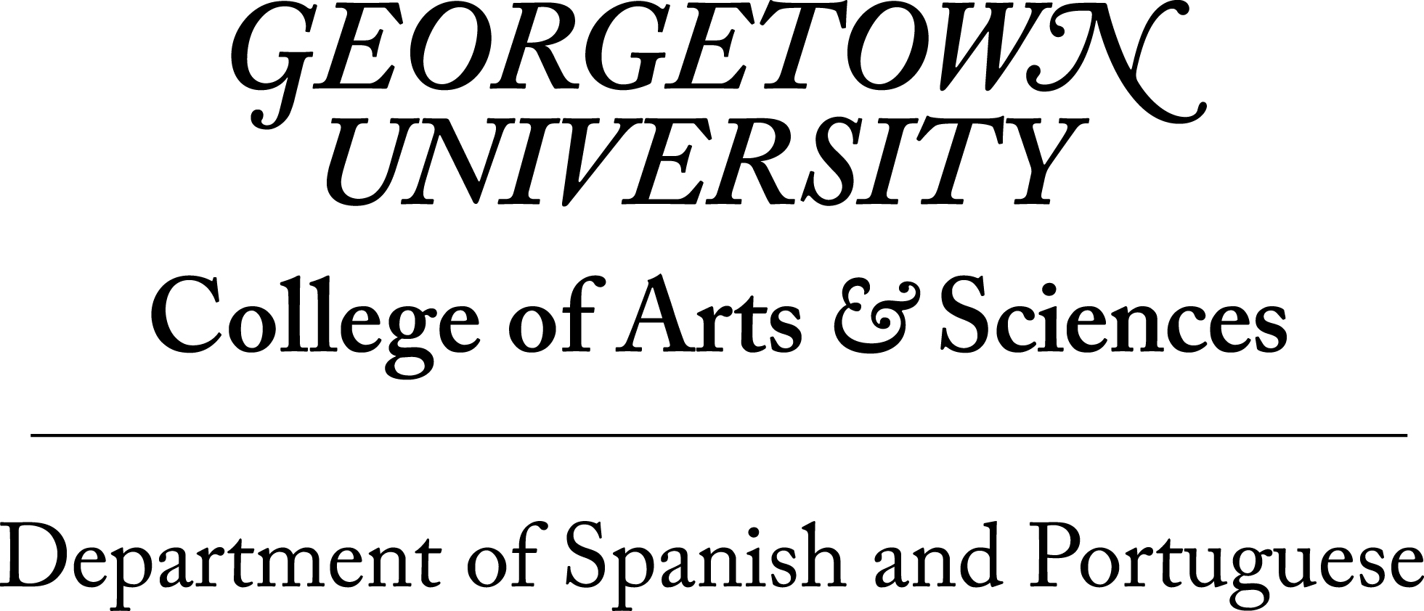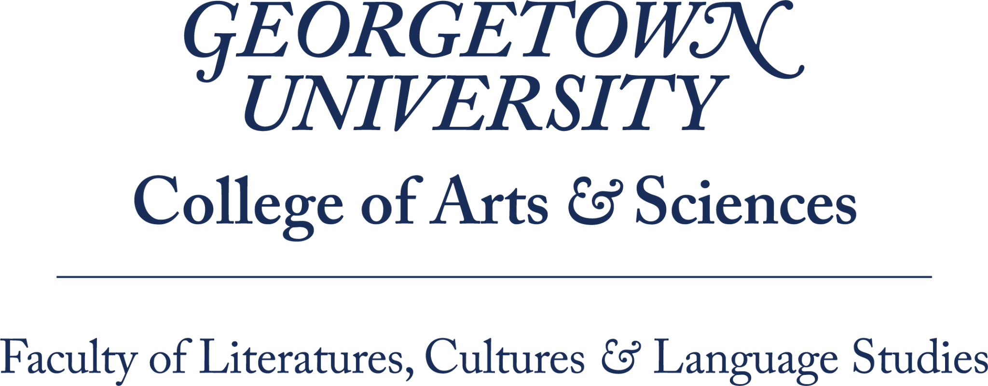

**17th GRAPHSY (Graduate Portuguese and Hispanic Symposium)**

Department of Spanish and Portuguese, Georgetown University - Washington, DC

***Emociones, sentimientos y afectos***  ***/* Emoções, sentimentos e afetos */***

***Emotions, feelings and affects***

**February 14, 2025 - Hybrid (In-Person and Online sessions)[1]**

**CALL FOR ABSTRACTS:**

The Department of Spanish and Portuguese at Georgetown University invites you to participate in its Graduate Portuguese and Hispanic Symposium 2025 (GRAPHSY). This year’s conference welcomes proposals within the theme of ***Emociones, sentimientos y afectos/ Emoções, sentimentos e afetos/ Emotions, feelings and affects*** encouraging the submission of a broad range of research in the fields of Linguistics, Iberian and Latin American Literatures, and Cultures. Emotions play a crucial role in how we understand the world and define our place within it. Although the study of emotions remains a challenging area in modern disciplines, this conference aims to lay a solid foundation for future research by focusing on the linguistic, literary, and cultural manifestations of emotional experiences. GRAPHSY 2025 invites us to reflect on questions related to both positive and negative emotions and language learning, the role of affect in cultural and literary analysis and criticism, the contributions of these new interpretive theories to the emerging post-critical moment in literary studies, the impact of feelings on the development of bi/multilingual identities as well as in various types of social interactions, among other issues.

This year, we are seeking papers that offer innovative readings of texts—from medieval to postmodern, including fiction, theater, poetry, and memoirs—through the lens of studies on affect, feelings, and emotions. We also welcome projects that investigate language in its relationship with emotions, as well as research examining the interconnection between language and human cognition.

We encourage submissions for GRAPHSY 2025, which will be held in a hybrid format on February 14, 2025. Abstracts should be related to the theme: Emotions, Feelings, and Affects; however, we are excited to receive innovative proposals that connect literature and linguistics with diverse fields, such as:

* Sound studies.
* Sociolinguistics, linguistic policies and ideologies.
* Impact on language learning and acquisition.
* Semantics and pragmatics.
* Critical theories and pedagogies.
* New technologies and Artificial Intelligence.
* Theater, music, and performance studies.
* Social sciences: economics, anthropology, history, political science, international relations, law, journalism.
* Visual arts: architecture, painting, drawing, photography, sculpture.

All graduate students can present either essays or posters. Undergraduate students will be considered for an exclusive panel or poster presentations. [**You can submit your abstract here**](https://docs.google.com/forms/d/1JkPSh_hdCfI_102Fg83qDrICEu-ZcYlTVqIwJ6b_9cE/viewform?edit_requested=true)**.**

**The deadline for the submission of proposals is January 6, 2025**. **There is no cost for presenters or registered attendees**.

If you have any questions, please contact us at [graphsy@georgetown.edu](mailto:graphsy@georgetown.edu) or see <https://spanport.georgetown.edu/graphsy/> for further details. You can also follow us on our social media: [Facebook,](https://www.facebook.com/Graphsy-2022-Graduate-Portuguese-and-Hispanic-Symposium-110933357335773/) [Instagram](https://www.instagram.com/graphsy2024/) y [X](https://x.com/graphsy_gu).

Andrea Hernando (Co-Chair, Linguistics)

Mariamnny Contreras (Co-Chair, Literature)

Laura Zalazar (Junior Co-Chair, Linguistics)

Allison Goldman (Junior Co-Chair, Linguistics)

L Angulo (Junior Co-Chair, Literature)

*GRAPHSY 2025 committee members*

1. Some panels will be hybrid and applicants will be allowed to present online. However, given that the hybrid slots are limited, the majority of presentations will be in person.